[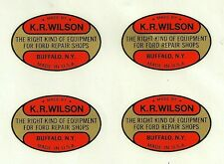](https://www.ebay.com/itm/K-R-Wilson-Water-Transfer-Decals-Set-of-4-Ford-Tools-Model-A-T-V8-V-8-KR-KRW/264320576312?hash=item3d8abbeb38:g:FisAAOSw43haA8T2)